National College of Computer Studies

Paknajol, Kathmandu

**Lab 3**

**Submitted by: Submitted to:**

Atullya Maharjan Prashant Gautam

BSc. CSIT 4th Semester NCCS

Roll. No: 05

1. **WAP to design a DFA for the language of string over {0,1} such that each string start with 01**

#include <iostream>

#include <string>

using namespace std;

int main(){

string str; // string to be checked

char state = 0; // initial state (q0)

cout << "Enter the string: ";

cin >> str;

for (int i = 0; i < str.length(); i++)

{

if (str[i] != '0' && str[i] != '1')

{

cout << "String not accepted.\nPlease enter a string over {0,1}" << endl;

return 0;

}

if (state == 0 && str[i] == '0')

state = 1;

else if (state == 0 && str[i] == '1')

state = 3;

else if (state == 1 && str[i] == '0')

state = 3;

else if (state == 1 && str[i] == '1')

state = 2;

else if (state == 2 && str[i] == '0')

state = 2;

else if (state == 2 && str[i] == '1')

state = 2;

else if ((state == 3 && str[i] == '0') || (state == 3 && str[i] == '1'))

state = 3;

}

if (state == 2)

cout << "String accepted";

else

cout << "String not accepted";

return 0;

}





1. **WAP to design a DFA for the language of string over {0,1} such that set of all string ending in 00**

#include <iostream>

#include <string>

using namespace std;

int main()

{

string str;

char state = 0; // initial state (q0)

cout << "Enter the string: ";

cin >> str;

for (int i = 0; i < str.length(); i++) {

if (str[i] != '0' && str[i] != '1')

{

cout << "String not accepted.\nPlease enter a string over {0, 1}" << endl;

return 0;

}

// dfa transition check

if (state == 0 && str[i] == '0')

state = 1;

else if (state == 0 && str[i] == '1')

state = 0;

else if (state == 1 && str[i] == '0')

state = 2;

else if (state == 1 && str[i] == '1')

state = 0;

else if (state == 2 && str[i] == '0')

state = 2;

else if (state == 2 && str[i] == '1')

state = 0;

}

if (state == 2)

cout << "String accepted";

else

cout << "String not accepted";

return 0;

}





1. **WAP to design a DFA for the language of string over {0,1} such that set of strings with 011 as a substring.**

#include <iostream>

#include <string>

using namespace std;

int main(){

string str;

char state = 0;

cout << "Enter the string: ";

cin >> str;

for (int i = 0; i < str.length(); i++) {

if (str[i] != '0' && str[i] != '1') {

cout << "String not accepted.\nPlease enter a string over {0,1}" << endl;

return 0;

}

if (state == 0 && str[i] == '0')

state = 1;

else if (state == 0 && str[i] == '1')

state = 0;

else if (state == 1 && str[i] == '0')

state = 1;

else if (state == 1 && str[i] == '1')

state = 2;

else if (state == 2 && str[i] == '0')

state = 1;

else if (state == 2 && str[i] == '1')

state = 3;

else if (state == 3 && str[i] == '0')

state = 3;

else if (state == 3 && str[i] == '1')

state = 3; }

if (state == 3)

cout << "String accepted";

else

cout << "String not accepted";

return 0;

}





4 Construct a nfa over alphabet ∑={0,1} that accepts string whose 3rd last element is 0.

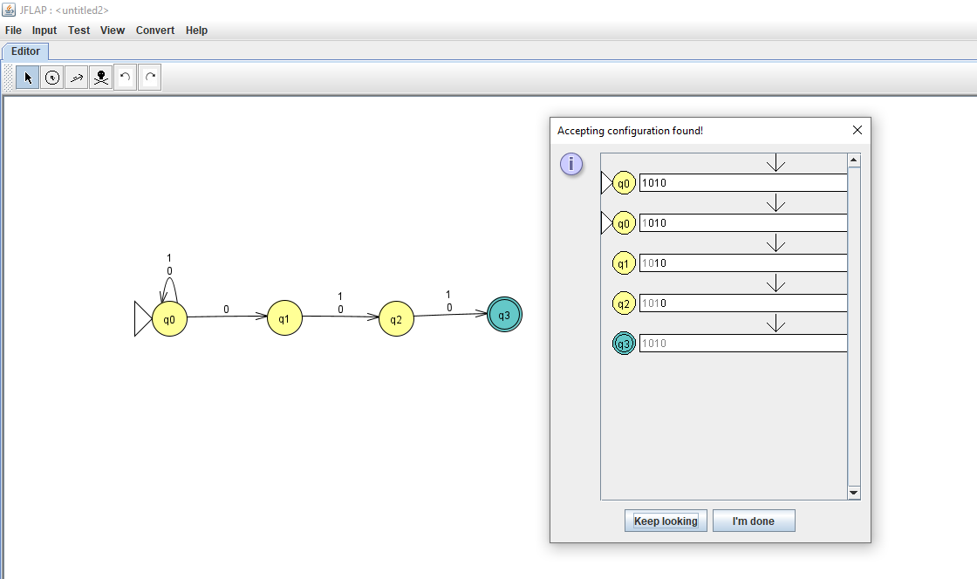

1. 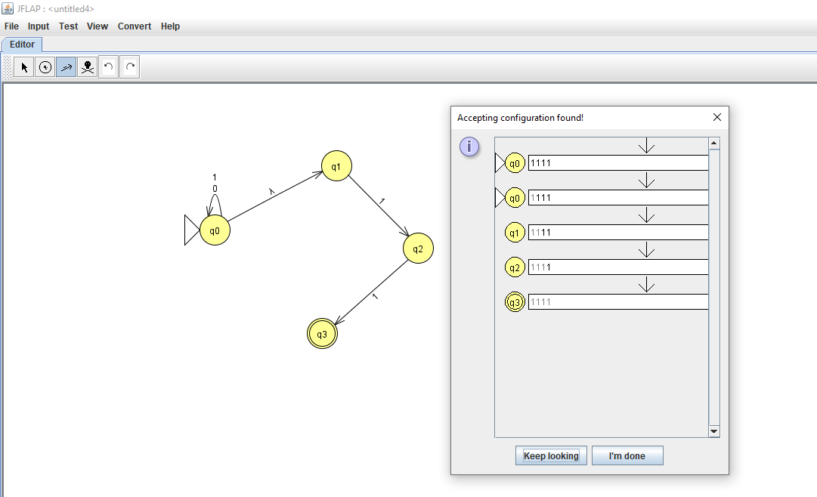Construct E-NFA over alphabet ∑={0,1} that accepts string ending with 11.

6 Construct E-NFA over alphabet ∑={0,1} that accepts string that has substring bb.

